AVEIR™ AR Atrial Leadless Pacemaker (LP) System
Medicare Coverage with Evidence Development Study Information: Institutional

This document summarizes billing information for the:
AVEIR™ AR Atrial Leadless Pacemaker (LP) System per the CMS NCD 20.8.4¹. It is the responsibility of the hospital and/or physician to determine appropriate coding for a particular patient and/or procedure. Any claim should be coded appropriately and supported with adequate documentation in the medical record.

CODES/MODIFIERS/OTHERS | WHEN USED?
DIAGNOSIS CODES
Applicable primary diagnosis codes | All cases
Z00.6*: Encounter for examination for normal comparison and control in clinical research program | All cases
Applicable secondary diagnosis codes | When appropriate
CPT, MODIFIER & HCPCS CODES
0823T: Insertion of a permanent single-chamber leadless pacemaker, right atrial | All outpatient cases
CPT Modifier Q0*: Investigational clinical service provided in a clinical research study that is in an approved clinical research study | All outpatient cases
ICD-10-PCS CODE
02H63NZ: AR Insertion | All inpatient cases
CONDITION CODE
30*: qualifying clinical trial | All cases
NCT NUMBER
06100770* | All cases
VALUE CODE
D4* | All cases

*These codes are required by The Centers of Medicare and Medicaid to be included on each Traditional Medicare and Medicare Advantage claim.

SAMPLE HOSPITAL OUTPATIENT CLAIM FORM
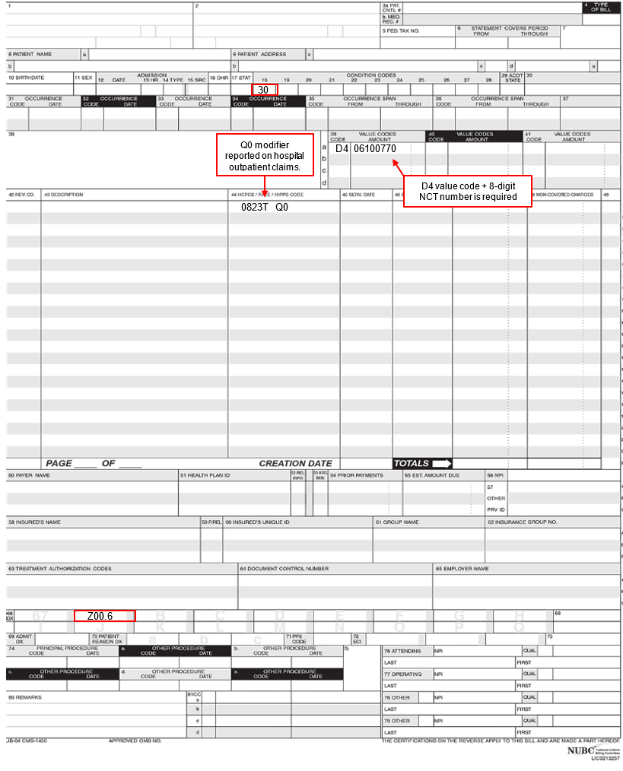

Important Safety Information
Rx only  Brief Summary: Prior to using these devices, please review the Instructions for Use for a complete listing of indications, contraindications, warnings, precautions, potential adverse events and directions for use.  Indications: The Aveir™ Leadless Pacemaker system is indicated for management of one or more of the following permanent conditions: Syncope, Pre-syncope, Fatigue, Disorientation. Rate-modulated pacing is indicated for patients with chronotropic incompetence, and for those who would benefit from increased stimulation rates concurrent with physical activity. Dual- chamber pacing is indicated for patients exhibiting: Sick sinus syndrome, Chronic, symptomatic second- and third-degree AV block , Recurrent Adams- Stokes syndrome, Symptomatic bilateral bundle-branch block when tachyarrhythmia and other causes have been ruled out. Atrial pacing is indicated for patients with: Sinus node dysfunction and normal AV and intraventricular conduction systems. Ventricular pacing is indicated for patients with: Significant bradycardia and normal sinus rhythm with only rare episodes of AV block or sinus arrest, Chronic atrial fibrillation, Severe physical disability. MR Conditional: The Aveir Leadless Pacemaker is conditionally safe for use in the MRI environment and according to the instructions in the MRI-Ready Leadless System Manual.  Intended Use: The Aveir™ Leadless Pacemaker (LP) is designed to provide bradycardia pacing as a pulse generator with built-in battery and electrodes for implantation in the right ventricle and/or right atrium. The LP is intended to provide sensing of intrinsic cardiac signals and delivery of cardiac pacing therapy within the implanted chamber for the target treatment group. The LP is also intended to operate optionally with another co-implanted LP to provide dual-chamber pacing therapy.  The Aveir™ Delivery Catheter is intended to be used in the peripheral vasculature and the cardiovascular system to deliver and manipulate an LP. Delivery and manipulation includes implanting an LP within the target chamber of the heart.  Contraindications: Use of the Aveir™ Leadless Pacemaker is contraindicated in these cases:  Use of any pacemaker is contraindicated in patients with a co-implanted ICD because high-voltage shocks could damage the pacemaker and the pacemaker could reduce shock effectiveness.  - Single-chamber ventricular demand pacing is relatively contraindicated in patients who have demonstrated pacemaker syndrome, have retrograde VA conduction, or suffer a drop in arterial blood pressure with the onset of ventricular pacing. | - Programming of rate-responsive pacing is contraindicated in patients with intolerance of high sensor driven rates.  - Use is contraindicated in patients with an implanted vena cava filter or mechanical tricuspid valve because of interference between these devices and the delivery system during implantation.  - Persons with known history of allergies to any of the components of this device may suffer an allergic reaction to this device. Prior to use on the patient, the patient should be counseled on the materials (listed in the Product Materials section of the IFU) contained in the device and a thorough history of allergies must be discussed.  Adverse Events: Potential complications associated with the use of the Aveir™ Leadless Pacemaker system are the same as with the use of single or dual chamber pacemakers with active fixation pacing leads including, but not limited to: Cardiac perforation, Cardiac tamponade, Pericardial effusion, Pericarditis, Endocarditis, Valve damage or regurgitation, Heart failure, Pneumothorax/hemothorax, Cardiac arrhythmias, Diaphragmatic/phrenic nerve stimulation / extra-cardiac stimulation, Palpitations, Hypotension, Syncope, Cerebrovascular accident, Infection, Hypersensitivity reaction to device materials, contrast media, medications, or direct toxic effect of contrast media on kidney function, Pacemaker syndrome, Inability to interrogate or program the LP due to programmer or LP malfunction, Intermittent or complete loss of capture, pacing or sensing (non-battery related), Oversensing, Increased capture threshold, Inappropriate sensor response, Corrupted, intermittent, or loss of i2i communications, Interruption of desired LP function due to electrical interference, either electromyogenic or electromagnetic, Battery malfunction/ premature battery depletion, Device-related complications (Premature deployment, Device dislodgement/embolization of foreign material, Inability to release/re-dock of the LP from the catheter, Helix distortion), Additional surgery or intervention, Death. As with any percutaneous catheterization procedure, potential complications include, but are not limited to: Vascular access complications; such as perforation, dissection, puncture, groin pain, Bleeding or hematoma, Thrombus formation, Thromboembolism, Air embolism, Local and systemic infection, Peripheral nerve damage. General surgery risks and complications from comorbidities; such as, dyspnea, respiratory failure, pneumonia, hypertension, cardiac failure, reaction to sedation, renal failure, anemia, and death.

CAUTION: This product is intended for use by or under the direction of a physician. Prior to use, reference the Instructions for Use, inside the product carton (when available) or at vascular.eifu.abbott or at manuals.eifu.abbott for more detailed information on Indications, Contraindications, Warnings, Precautions and Adverse Events. This material is intended for use with healthcare professionals only.

References:
- National Coverage Determination Leadless Pacemakers 20.8.4: NCD - Leadless Pacemakers (20.8.4) (cms.gov)
- Medicare Claims Processing Manual, Chapter 32, Section 380 - Leadless Pacemakers: Medicare Claims Processing Manual (cms.gov)
- CMS UB-04 Form: Interactive UB-04 (palmettogba.com)
- 2024 ICD-10-PCS. https://www.cms.gov/medicare/icd-10/2024-icd-10-pcs
- 2024 ICD-10-CM. https://www.cms.gov/medicare/icd-10/2024-icd-10-cm

Disclaimer
This material and the information contained herein is for general information purposes only and is not intended, and does not constitute, legal, reimbursement, business, clinical, or other advice. Furthermore, it is not intended to and does not constitute a representation or guarantee of reimbursement, payment, or charge, or that reimbursement or other payment will be received. It is not intended to increase or maximize payment by any payer. Abbott makes no express or implied warranty or guarantee that the list of codes and narratives in this document is complete or error-free. Similarly, nothing in this document should be viewed as instructions for selecting any particular code, and Abbott does not advocate or warrant the appropriateness of the use of any particular code. The ultimate responsibility for coding and obtaining payment/reimbursement remains with the customer. This includes the responsibility for accuracy and veracity of all coding and claims submitted to third-party payers. In addition, the customer should note that laws, regulations, and coverage policies are complex and are updated frequently and is subject to change without notice. The customer should check with its local carriers or intermediaries often and should consult with legal counsel or a financial, coding, or reimbursement specialist for any questions related to coding, billing, reimbursement, or any related issues. This material reproduces information for reference purposes only. It is not provided or authorized for marketing use.

Information contained herein for DISTRIBUTION in the U.S. ONLY.

Abbott
3200 Lakeside Dr., Santa Clara, CA 95054 USA Tel: 1.800.227.9902
www.cardiovascular.abbott
™ Indicates a trademark of the Abbott group of companies
‡ Indicates third party trademark, which is the property of its respective owner.
©2024 Abbott. All rights reserved.
MAT-2405367 v1.0 | Item approved for U.S. use only.

